DATA ANALYTICS PORTFOLIO PROJECT
SQL Business Findings
Retail Sales Analysis – MySQL analysis report
AUTHOR
Aaditya Mahajan
PROJECT TYPE
Independent Data Analytics Portfolio Project
DATASET
Synthetic retail sales data – 5,000 transactions, January–December 2025
TECHNOLOGY
MySQL Workbench (database retail_sales_db, table retail_sales)
DATE
November 2026

Data note
This project uses a synthetic dataset created for learning and portfolio demonstration. It does not represent a real company or real customer transactions. All financial figures are in Indian Rupees (₹).

1. SQL Analysis Overview
This report presents the results of the SQL analysis performed on the Retail Sales dataset in MySQL. The script (Retail_Sales_Analysis.sql) validates the imported data, converts the order date to a proper DATE type, and then answers business questions about revenue, profit, categories, months, cities, products, payment modes, sales channels and discounts.
Revenue and profit are reported separately throughout. In the dataset, Sales is the net sales value after discount (labelled Total Revenue in the SQL output) and *Profit* equals Sales minus Cost. Profit margin is Profit ÷ Sales.
Item | Detail
Database / table | retail_sales_db.retail_sales
Records analysed | 5,000 (one row per order)
Period | 1 January 2025 – 31 December 2025
Currency | Indian Rupee (₹)
Analysis blocks | Validation (4), KPIs (1), category, monthly (2 queries), city, product, payment mode, channel, discount
Data source | Synthetic dataset – not real company data

How the figures in this report were verified
Every result below was recomputed independently from Retail_Sales_Cleaned.csv by replicating each query's logic. The overall KPIs, channel figures and discount figures match those quoted in the project README. The raw MySQL output screens were not supplied, so confirm that the MySQL table was loaded from the cleaned CSV before publishing.

2. Total Business KPIs
The first analytical query summarises the whole dataset.
SELECT ROUND(SUM(Sales), 2) AS Total_Revenue,
ROUND(SUM(Profit), 2) AS Total_Profit,
COUNT(DISTINCT OrderID) AS Total_Orders,
COUNT(DISTINCT CustomerID) AS Unique_Customers,
SUM(Quantity) AS Total_Quantity_Sold,
ROUND(SUM(Sales) / COUNT(DISTINCT OrderID), 2) AS Average_Order_Value
FROM retail_sales_db.retail_sales;

KPI | Result
Total revenue (Sales) | ₹41,949,595.29
Total cost | ₹28,222,692.98
Total profit | ₹13,726,902.31
Overall profit margin (Profit ÷ Sales) | 32.72%
Total orders | 5,000
Unique customers | 500
Total quantity sold | 11,854
Average order value | ₹8,389.92

Total cost and overall margin are derived from the same data (cost = revenue − profit); they are not separate outputs of the script. On average each customer placed 10 orders (range 2–20).

3. Duplicate Order Validation
SELECT COUNT(*) AS total_rows,
COUNT(DISTINCT OrderID) AS unique_orders,
COUNT(*) - COUNT(DISTINCT OrderID) AS duplicate_orders
FROM retail_sales_db.retail_sales;

Metric | Result
Total rows | 5,000
Unique orders | 5,000
Duplicate orders | 0

Finding: each OrderID appears exactly once, so order-level counts and averages are not inflated by duplicates. No fully duplicated rows exist either.
Script note
Line 8 of the SQL file ends with a stray backslash after the semicolon (";\"). Remove it before re-running the script in MySQL Workbench.

4. Missing Value Validation
SELECT
SUM(CASE WHEN CustomerName IS NULL OR TRIM(CustomerName) = ''
THEN 1 ELSE 0 END) AS missing_customer_names,
SUM(CASE WHEN PaymentMode IS NULL OR TRIM(PaymentMode) = ''
THEN 1 ELSE 0 END) AS missing_payment_modes,
SUM(CASE WHEN OrderDate IS NULL OR TRIM(OrderDate) = ''
THEN 1 ELSE 0 END) AS missing_order_dates
FROM retail_sales_db.retail_sales;

Check | Blank / NULL count (cleaned data)
Missing customer names | 0
Missing payment modes | 0
Missing order dates | 0

Finding: no blank or NULL values remain in the three fields tested (in fact, none in any of the 19 columns). This is the expected result of the Power Query cleaning step, which replaced missing customer names and payment modes with the text "Unknown".
What the check does not detect
The query tests for blank and NULL only, so the placeholder "Unknown" is not flagged. The cleaned data contains 20 orders with CustomerName = "Unknown" and 15 orders with PaymentMode = "Unknown" (0.40% and 0.30% of orders). "Unknown" is therefore its own group in the payment-mode analysis (Section 10).

5. Date Validation
OrderDate is held as text in m/d/yyyy format, so the script adds a DATE column and converts it with STR_TO_DATE before any time-based analysis.
ALTER TABLE retail_sales_db.retail_sales ADD COLUMN Order_Date DATE;

UPDATE retail_sales_db.retail_sales
SET Order_Date = STR_TO_DATE(OrderDate, '%c/%e/%Y');

SELECT COUNT(*) AS total_records, COUNT(Order_Date) AS valid_dates,
MIN(Order_Date) AS first_order_date, MAX(Order_Date) AS last_order_date
FROM retail_sales_db.retail_sales;

Metric | Result
Total records | 5,000
Valid dates (non-NULL after conversion) | 5,000
First order date | 2025-01-01
Last order date | 2025-12-31

Finding: all 5,000 dates converted successfully and fall within calendar year 2025. Every one of the 365 days of the year has at least one order. The conversion format %c/%e/%Y accepts dates without leading zeros (e.g., 9/6/2025), matching the source file.

6. Category Performance
SELECT Category, COUNT(*) AS Total_Orders, SUM(Quantity) AS Total_Quantity,
ROUND(SUM(Sales), 2) AS Total_Revenue, ROUND(SUM(Profit), 2) AS Total_Profit,
ROUND(SUM(Profit) / SUM(Sales) * 100, 2) AS Profit_Margin_Percent
FROM retail_sales_db.retail_sales
GROUP BY Category ORDER BY Total_Revenue DESC;

Category | Orders | Quantity | Revenue (₹) | Profit (₹) | Margin | Revenue share
Furniture | 1,517 | 3,630 | 21,619,078.18 | 7,561,255.63 | 34.97% | 51.54%
Electronics | 2,043 | 4,831 | 17,751,456.40 | 4,892,820.83 | 27.56% | 42.32%
Accessories | 727 | 1,754 | 2,029,842.52 | 961,415.75 | 47.36% | 4.84%
Stationery | 713 | 1,639 | 549,218.19 | 311,410.10 | 56.70% | 1.31%

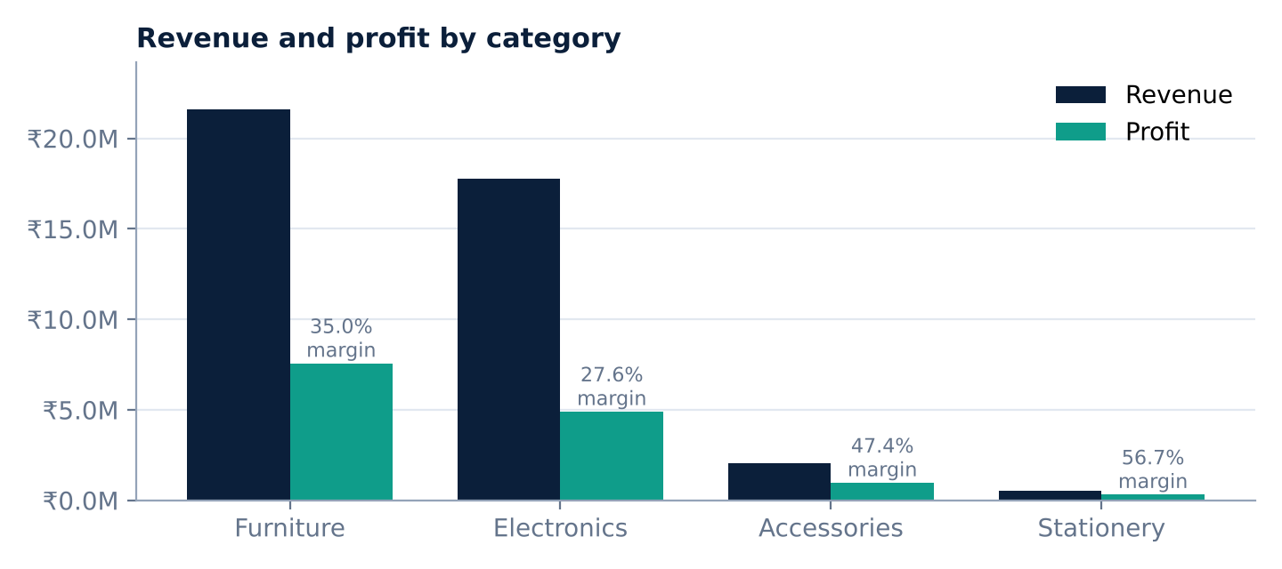
Figure 1 – Revenue and profit by category (labels show profit margin).
- Furniture leads on both revenue (₹21,619,078.18, 51.54% of total) and profit (₹7,561,255.63), with a 34.97% margin.
- Electronics is second on revenue (₹17,751,456.40) and has the most orders (2,043), but the lowest margin of the two large categories (27.56%).
- Accessories (47.36%) and Stationery (56.70%) earn the highest margins but together contribute only 6.15% of revenue because their average order values are small (₹2,792.08 and ₹770.29).
Supplementary check (not in the SQL script)
Grouping by SubCategory shows that within Electronics, Monitors (17.42% margin) and Printers (21.01%) earn markedly lower margins than Accessories (38.68%) and Audio (43.28%). Sub-category names are not unique across categories, so Category and SubCategory should be used together.

7. Monthly Revenue and Profit Analysis
Two queries analyse months: the first lists each month chronologically (grouped by year, month number and month name); the second ranks months by revenue.
SELECT YEAR(Order_Date) AS Sales_Year, MONTH(Order_Date) AS Sales_Month,
MONTHNAME(Order_Date) AS Month_Name, ROUND(SUM(Sales), 2) AS Total_Revenue,
ROUND(SUM(Profit), 2) AS Total_Profit, COUNT(*) AS Total_Orders
FROM retail_sales_db.retail_sales
GROUP BY YEAR(Order_Date), MONTH(Order_Date), MONTHNAME(Order_Date)
ORDER BY Sales_Year, Sales_Month;

Month | Orders | Revenue (₹) | Profit (₹) | Margin
January | 460 | 3,887,393.02 | 1,188,963.93 | 30.59%
February | 358 | 3,219,804.36 | 1,047,579.37 | 32.54%
March | 459 | 3,638,960.38 | 1,183,465.55 | 32.52%
April | 389 | 3,442,170.34 | 1,125,651.38 | 32.70%
May | 432 | 3,444,666.99 | 1,124,700.45 | 32.65%
June | 396 | 3,764,142.37 | 1,248,064.51 | 33.16%
July | 434 | 3,693,474.02 | 1,239,234.53 | 33.55%
August | 411 | 3,163,175.57 | 1,071,307.02 | 33.87%
September | 439 | 3,662,787.33 | 1,198,167.49 | 32.71%
October | 420 | 3,394,563.80 | 1,110,395.99 | 32.71%
November | 369 | 3,198,930.89 | 1,062,152.03 | 33.20%
December | 433 | 3,439,526.22 | 1,127,220.06 | 32.77%
Total | 5,000 | 41,949,595.29 | 13,726,902.31 | 32.72%

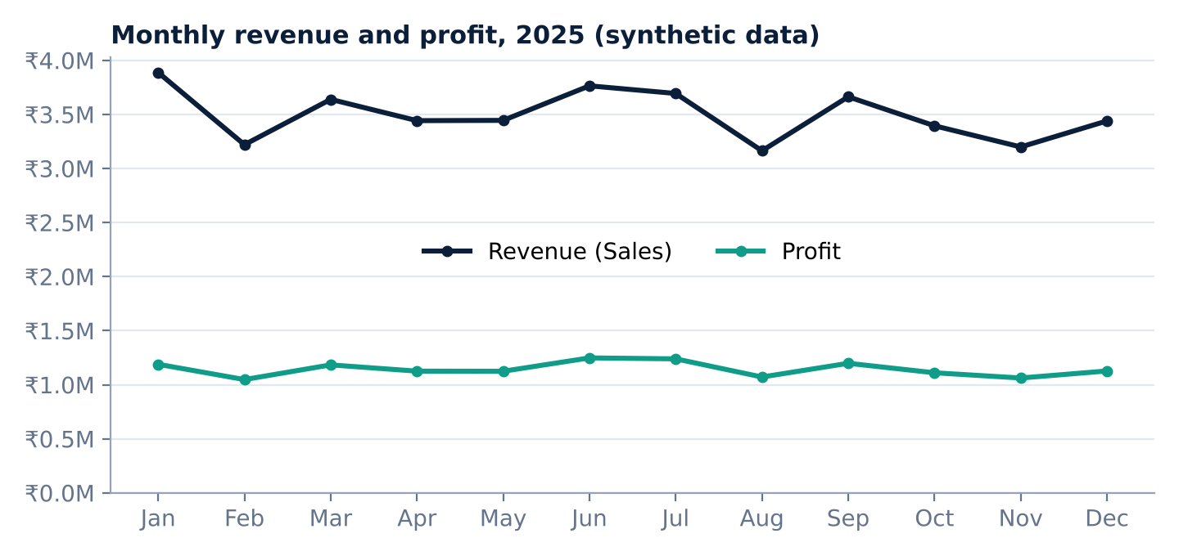
Figure 2 – Monthly revenue and profit, 2025.
Rank (by revenue) | Month | Revenue (₹) | Profit (₹)
1 | January | 3,887,393.02 | 1,188,963.93
2 | June | 3,764,142.37 | 1,248,064.51
3 | July | 3,693,474.02 | 1,239,234.53
10 | February | 3,219,804.36 | 1,047,579.37
11 | November | 3,198,930.89 | 1,062,152.03
12 | August | 3,163,175.57 | 1,071,307.02

- January is the highest-revenue month (₹3,887,393.02) but has the lowest margin of the year (30.59%); August has the lowest revenue (₹3,163,175.57) and the highest margin (33.87%).
- Quarterly revenue declines gradually: Q1 ₹10,746,157.76, Q2 ₹10,650,979.70, Q3 ₹10,519,436.92, Q4 ₹10,033,020.91 (Q4 is 6.6% below Q1).
- Monthly revenue ranges only from ₹3.16M to ₹3.89M, so month-to-month swings are moderate.
Caution: the dataset is synthetic and covers a single year, so these patterns should not be interpreted as real seasonality or as evidence of a long-term trend.

8. City Performance
SELECT City, COUNT(*) AS Total_Orders, ROUND(SUM(Sales), 2) AS Total_Revenue,
ROUND(SUM(Profit), 2) AS Total_Profit,
ROUND(SUM(Profit) / SUM(Sales) * 100, 2) AS Profit_Margin_Percent
FROM retail_sales_db.retail_sales GROUP BY City ORDER BY Total_Revenue DESC;

City | Orders | Revenue (₹) | Profit (₹) | Margin | Revenue share
Mumbai | 539 | 4,719,776.09 | 1,549,352.02 | 32.83% | 11.25%
Mysuru | 506 | 4,596,319.54 | 1,501,285.34 | 32.66% | 10.96%
Nashik | 520 | 4,354,026.07 | 1,383,228.24 | 31.77% | 10.38%
Bengaluru | 502 | 4,298,360.44 | 1,453,682.57 | 33.82% | 10.25%
Nagpur | 515 | 4,102,747.65 | 1,341,315.48 | 32.69% | 9.78%
Chennai | 509 | 4,088,847.92 | 1,298,574.24 | 31.76% | 9.75%
Jaipur | 502 | 4,078,409.69 | 1,366,457.97 | 33.50% | 9.72%
Pune | 486 | 4,052,957.01 | 1,318,372.65 | 32.53% | 9.66%
Hyderabad | 452 | 3,930,073.71 | 1,253,496.27 | 31.89% | 9.37%
Delhi | 469 | 3,728,077.17 | 1,261,137.53 | 33.83% | 8.89%

- Mumbai ranks first (₹4,719,776.09; 11.25% of revenue); Delhi ranks last (₹3,728,077.17; 8.89%).
- Performance is evenly spread: every city contributes between 8.89% and 11.25% of revenue and margins range from 31.76% to 33.83%.
- Delhi combines the lowest revenue with the highest margin (33.83%), and Hyderabad has the fewest orders (452).

9. Top-Performing Products
SELECT ProductID, ProductName, Category, SUM(Quantity) AS Total_Quantity_Sold,
ROUND(SUM(Sales), 2) AS Total_Revenue, ROUND(SUM(Profit), 2) AS Total_Profit
FROM retail_sales_db.retail_sales
GROUP BY ProductID, ProductName, Category
ORDER BY Total_Revenue DESC LIMIT 10;

# | Product | Category | Qty | Revenue (₹) | Profit (₹) | Margin
1 | Standing Desk - Model 022 (P022) | Furniture | 125 | 1,722,199.04 | 650,725.29 | 37.78%
2 | Standing Desk - Model 042 (P042) | Furniture | 132 | 1,716,751.55 | 743,834.99 | 43.33%
3 | Standing Desk - Model 062 (P062) | Furniture | 116 | 1,553,531.09 | 751,163.73 | 48.35%
4 | Standing Desk (P002) | Furniture | 128 | 1,472,500.00 | 474,100.00 | 32.20%
5 | LED Monitor 24in - Model 045 (P045) | Electronics | 135 | 1,392,975.70 | 541,599.55 | 38.88%
6 | Standing Desk - Model 082 (P082) | Furniture | 137 | 1,359,120.60 | 305,135.76 | 22.45%
7 | Printer (P016) | Electronics | 140 | 1,139,200.00 | 229,200.00 | 20.12%
8 | Printer - Model 076 (P076) | Electronics | 133 | 1,124,416.74 | 345,550.12 | 30.73%
9 | Printer - Model 056 (P056) | Electronics | 144 | 1,097,696.45 | 177,223.97 | 16.15%
10 | LED Monitor 24in - Model 065 (P065) | Electronics | 126 | 1,012,127.72 | 86,404.46 | 8.54%

- The top 10 products generate 32.40% of total revenue; five are Standing Desk variants, three are Printers and two are LED Monitors.
- Margins within the top 10 vary widely – from 8.54% (LED Monitor 24in – Model 065) to 48.35% (Standing Desk – Model 062) – so revenue rank is not a reliable guide to profitability.
- Product name is unique per ProductID, so ranking by ProductID matches the "Top 10 Product Name" chart in the Power BI dashboard.

10. Payment Mode Analysis
SELECT PaymentMode, COUNT(*) AS Total_Orders, ROUND(SUM(Sales), 2) AS Total_Revenue,
ROUND(SUM(Profit), 2) AS Total_Profit,
ROUND(COUNT(*) * 100.0 / (SELECT COUNT(*) FROM retail_sales_db.retail_sales), 2) AS Order_Percentage
FROM retail_sales_db.retail_sales GROUP BY PaymentMode ORDER BY Total_Revenue DESC;

Payment mode | Orders | Order % | Revenue (₹) | Profit (₹) | Margin
UPI | 2,062 | 41.24% | 17,723,734.66 | 5,811,853.16 | 32.79%
Credit Card | 1,089 | 21.78% | 8,804,626.09 | 2,842,233.83 | 32.28%
Debit Card | 847 | 16.94% | 7,104,955.23 | 2,318,791.64 | 32.64%
Cash | 585 | 11.70% | 4,704,646.90 | 1,536,549.39 | 32.66%
Net Banking | 402 | 8.04% | 3,467,852.07 | 1,162,114.88 | 33.51%
Unknown | 15 | 0.30% | 143,780.34 | 55,359.41 | 38.50%

- UPI is the dominant mode: 41.24% of orders and 42.25% of revenue. UPI plus cards (credit and debit) account for 80.18% of revenue; Cash is 11.21%.
- Margins are almost identical across the five named modes (32.28%–33.51%), so payment mode does not appear to be a profitability driver in this dataset.
- The "Unknown" group (15 orders) shows a 38.50% margin, but with so few orders this should not be interpreted.

11. Sales Channel Analysis
SELECT SalesChannel, COUNT(*) AS Total_Orders, SUM(Quantity) AS Total_Quantity,
ROUND(SUM(Sales), 2) AS Total_Revenue, ROUND(SUM(Profit), 2) AS Total_Profit,
ROUND(SUM(Profit) / SUM(Sales) * 100, 2) AS Profit_Margin_Percent
FROM retail_sales_db.retail_sales GROUP BY SalesChannel ORDER BY Total_Revenue DESC;

Channel | Orders | Quantity | Revenue (₹) | Profit (₹) | Margin | Avg order value (₹)
Online | 2,869 | 6,707 | 23,942,766.57 | 7,780,505.86 | 32.50% | 8,345.34
Store | 2,131 | 5,147 | 18,006,828.72 | 5,946,396.45 | 33.02% | 8,449.94

- Online generates more revenue (₹23,942,766.57, 57.08%) and more orders (2,869); Store earns a slightly higher margin (33.02% vs 32.50%).
- Average order value is nearly the same in both channels (₹8,345.34 online vs ₹8,449.94 in store). The margin gap is only 0.52 percentage points.

12. Discount Analysis
SELECT DiscountPct, COUNT(*) AS Total_Orders, ROUND(SUM(Sales), 2) AS Total_Revenue,
ROUND(SUM(Profit), 2) AS Total_Profit, ROUND(AVG(DiscountPct), 2) AS Average_Discount
FROM retail_sales_db.retail_sales GROUP BY DiscountPct ORDER BY DiscountPct;

DiscountPct is stored as a fraction (0.10 = 10%), so Average_Discount repeats the group value. Margin below is calculated as Profit ÷ Sales for each group.
Discount | Orders | Order % | Revenue (₹) | Profit (₹) | Margin
0% | 1,486 | 29.72% | 13,503,084.26 | 5,157,300.40 | 38.19%
5% | 907 | 18.14% | 7,473,172.69 | 2,611,285.06 | 34.94%
10% | 1,230 | 24.60% | 10,445,942.85 | 3,285,583.32 | 31.45%
15% | 787 | 15.74% | 6,260,931.93 | 1,796,381.25 | 28.69%
20% | 426 | 8.52% | 3,104,999.05 | 688,855.36 | 22.19%
25% | 164 | 3.28% | 1,161,464.51 | 187,496.92 | 16.14%

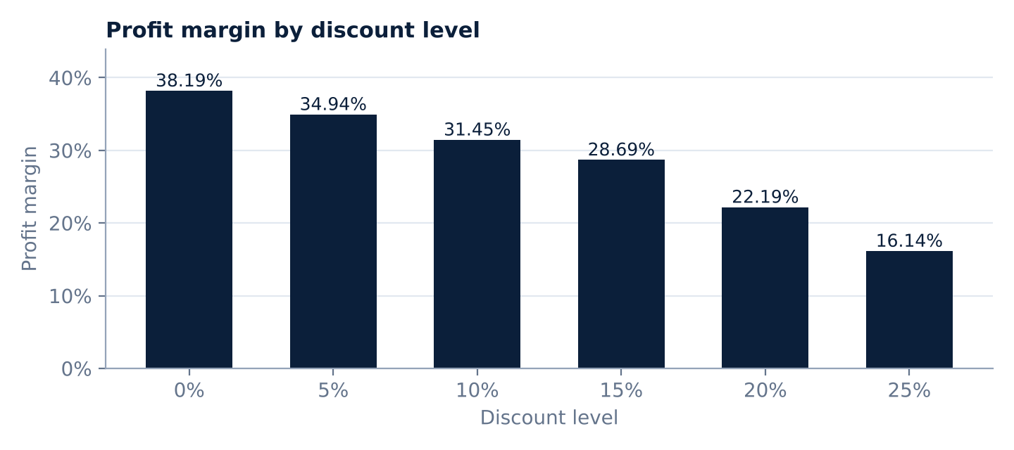
Figure 3 – Profit margin falls as the discount level rises.
- Orders with no discount produce the highest profit (₹5,157,300.40, 37.57% of total) at a 38.19% margin.
- The 25% group produces the lowest profit (₹187,496.92) at the lowest margin (16.14%).
- Orders discounted by 20% or 25% make up 11.80% of orders and 10.17% of revenue but only 6.38% of profit (combined margin 20.54%).
Interpreting the discount results
These are group-level comparisons and do not prove that discounts caused lower or higher business results. What the data does show:
• Sales are calculated as Quantity × UnitPrice × (1 − Discount) while cost is unchanged, so a deeper discount mechanically lowers the margin on the same product.
• Average units per order do not rise with the discount (2.42 at 0%, 2.39 at 10%, 2.26 at 25%), so the data gives no evidence that deeper discounts led to larger baskets.
• Category mix is similar across discount levels, so the margin differences are not explained by a shift toward low-margin categories.
• Supplementary check: all 50 loss-making orders (combined loss ₹52,062.01) carry discounts of 15% or more (6 at 15%, 26 at 20%, 18 at 25%).

13. Key Business Insights
- Revenue is concentrated in two categories. Furniture and Electronics produce 93.85% of revenue; Furniture alone provides 55.08% of profit.
- Profit margin differs more by category than by city, channel or payment mode. Category margins range from 27.56% to 56.70%, whereas city margins stay within about 2 points and channel and named payment-mode margins within about 1.2 points.
- Discounting is the clearest margin lever visible in the data. Margin falls from 38.19% with no discount to 16.14% at 25%.
- Revenue and profit rankings do not always agree. January is the top revenue month yet has the lowest margin; Accessories and Stationery rank low on revenue but high on margin.
- Sales are broad-based. Online produces 57.08% of revenue, and no city exceeds 11.25%; UPI is the leading payment mode (42.25%).
- Product revenue is spread across many products – the top 10 of 100 products contribute 32.40% of revenue.

14. Actionable Business Recommendations
The recommendations follow from the results above. Because the dataset is synthetic, they illustrate how the analysis would be used in practice and should be validated with real business data and controlled tests before any decision.
# | Recommendation | Supporting evidence
1 | Set guardrails for discounts of 20% and above, especially on low-margin Electronics (monitors, printers). | Margin drops to 22.19% (20%) and 16.14% (25%); all 50 loss-making orders carry ≥15% discounts; no higher units per order at deeper discounts.
2 | Test discount effectiveness before extending it: run controlled comparisons of discounted vs non-discounted offers. | Group comparisons cannot isolate a causal effect.
3 | Review pricing and cost of the lowest-margin products among the top sellers (e.g., LED Monitor 24in – Model 065). | Revenue rank 10 but margin 8.54%.
4 | Grow the high-margin, low-share categories through bundling or cross-sell with Furniture and Electronics purchases. | Accessories 47.36% and Stationery 56.70% margins but 6.15% combined revenue share. Absolute profit per order is small, so expect a modest uplift.
5 | Protect the Furniture category, the main profit engine, and keep its discounting disciplined. | 55.08% of total profit.
6 | Investigate the gradual revenue decline across quarters with real data (traffic, pricing, stock, promotions). | Q4 revenue 6.6% below Q1 in this dataset.
7 | Look at growth in Delhi and Hyderabad, where revenue or order volume is lowest and margin is healthy. | Delhi: lowest revenue, highest margin (33.83%); Hyderabad: fewest orders (452).
8 | Keep both channels and optimise each rather than favouring one; consider UPI-first checkout. | Channel margins differ by 0.52 points; UPI is 42.25% of revenue.
9 | Improve data capture so customer name and payment mode are recorded at source. | 20 unknown names and 15 unknown payment modes remain; names are recoverable through CustomerID.

15. Conclusion
The SQL analysis shows a dataset that is clean and consistent – 5,000 unique orders, valid dates throughout 2025 and no blank values – generating ₹41,949,595.29 in revenue and ₹13,726,902.31 in profit (32.72% margin) from 500 customers. Furniture is the leading category for both revenue and profit, sales are evenly spread across ten cities and two channels, and discount level is the factor most visibly associated with lower margin.
The analysis demonstrates data validation, date handling, aggregation, ranking, subqueries and business interpretation in MySQL, with a clear distinction between revenue and profit. Findings describe patterns in synthetic data and are not claims of causation.

